## Objectives:

Computer Practical – Week 1

#### The aim of this week’s practical includes:

* To get to know Packet Tracer, a network simulator to be used throughout the study period.
* To understand Packet Tracer Activity and how to use a .pka file
* To consolidate your understanding of some of the key concepts of networking devices and different types of networks

**Tasks:**

Accordingly you will need to complete the following tasks in this week’s computer practical

class:

1. Video – Packet Tracer Navigation
2. Video - Introduction to Packet Tracer Activities (.pka files)
3. Packet Tracer activity - Introduction to Packet Tracer
4. Packet Tracer activity – Network Representation

Instructions of the activities are given on the next pages.

**Video – Packet Tracer Navigation**

**Objectives**

Overview of the Packet Tracer Program

**Background**

Packet Tracer is a fun, take-home, flexible software program which will help you with your Cisco Certified Network Associate (CCNA) studies. Packet Tracer allows you to experiment with network behavior, build network models, and ask "what if" questions.

In this activity, you will watch a video which introduces Packet Tracer.

**Note**: It is not important that you understand everything when you watch the video for the first time. In this week, you will also have other activities to do so that you will learn more about Packet Tracer, and throughout the study period, you will use Packet Tracer constantly and will become master of the program!

### Step 1: Watch the following video tutorial about Packet Tracer

<http://youtu.be/any2NbeSZV4>(~9 minutes)

**Step 2: Navigate Packet Tracer**

Launch Packet Tracer on the PC in use. Following the illustration given in the video, create and configure the small network (two PCs and a switch), and test the connectivity between the two PCs using the Ping command.

**Checkpoint: please ask your supervisor to check the network you have created and tested.**

Download and watch the video named “Intro-PT-Activity-File-User-Profile.mp4” from “Computer

Practical – Week 1” folder

**Packet Tracer – Introduction to Packet Tracer**

**Before start:**

1. Download from course site (Computer Practical – Week 1 folder) the Packet Tracer activity file named**: week1-computer-prac-PKA-a-IntroPT.pka**
2. Open the above downloaded Packet Tracer activity file
3. Set up your **User Profile** by typing in your Full Name and UniSA email address in the User Profile window popped up.
4. Follow the instruction below to complete this activity.

**Topology**

Nearly complete logical topology provided as starting point.

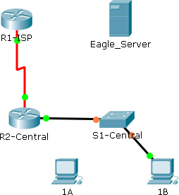

### Addressing Table

|  |  |  |  |  |  |
| --- | --- | --- | --- | --- | --- |
| **Device** |  | **Interface** | **IP Address** | **Subnet Mask** | **Default Gateway** |
| **R1-ISP** |  | **Fa0/0** | 192.168.254.253 | 255.255.255.0 | N/A |
| **S0/0/0** | 10.10.10.6 | 255.255.255.252 |
| **R2-**  **Central** |  | **Fa0/0** | 172.16.255.254 | 255.255.0.0 | N/A |
| **S0/0/0** | 10.10.10.5 | 255.255.255.252 |
| **S1-**  **Central** |  | **VLAN 1** | 172.16.254.1 | 255.255.0.0 | 172.16.255.254 |
| **PC 1A** |  | **NIC** | 172.16.1.1 | 255.255.0.0 | 172.16.255.254 |
| **PC 1B** |  | **NIC** | 172.16.1.2 | 255.255.0.0 | 172.16.255.254 |
| **Eagle Server** |  | **NIC** | 192.168.254.254 | 255.255.255.0 | 192.168.254.253 |

**Learning Objectives**

* + Get familiar with a Packet Tracer activity (.pka) file
  + Explore the Logical Workspace
  + Explore Packet Tracer operation
  + Connect devices
  + Examine a device configuration
  + Review a network topology
  + Overview of the devices

### Background

Throughout the course, you will be setting up some networks from actual PCs, servers, routers, and switches to learn networking concepts. This method provides widest range of features and the most realistic experience.

Since equipment and time are limited, this experience can be supplemented by a simulated environment. The simulator that is used in this course is Packet Tracer. Packet Tracer provides a rich set of protocols, equipment, and features but only a fraction of what is possible with real equipment.

### Part 1: Explore the two windows of a .pka file

##### Step 1: Arrange the two windows

When you launched this activity (a .pka file), you will see the activity instruction window and the workspace (normal PT) window. Arrange the windows so that you can see both at the same time.

On the activity instruction window, check your current completion rate of this activity. It should be 0% for now.

##### Step 2: View Activity Results

Click on the **Check Results** button shown at the left bottom of the activity instruction window, the Activity Results window should be shown.

Click on the **Assessment Items** tab, you should see some red crosses in the left pane, and your score on the right.

Click on the Close button to close the Activity Result window.

### Part 2: Explore the PT interface

##### Step 1: Logical Workplace

When Packet Tracer starts, it presents a logical view of the network in real-time mode. The main part of the PT interface is the **Logical Workplace**. This is the large area where devices are placed and connected.

##### Step 2: Symbols Navigation

In the lower left area of the PT interface is where can select devices and media/connections, and place them into the logical workplace. The first box in the lower left contains symbols that represent groups of devices. As you move the mouse pointer over these symbols, the name of the group appears in the text box in the center. When you click on one of these symbols, the specific devices/connections in the group appear in the box to the right. As you point to the specific devices/connections, a description of the device appears in the text box below the specific devices/connections. Click on each of the groups and study the various devices that are available and their symbols.

### Part 3: Explore PT operations

##### Step 1: Connect the devices using auto connect

Click on the connections group symbol. The specific connection symbols provide different cable types that can be used to connect devices. The first specific type, the gold lightning bolt, will automatically select the connection type based on the interfaces available on the devices. When you click on this symbol, the pointer resembles a cable connector.

To connect two devices click the auto connection symbol, click the first device, and then click the second device. Using the auto connection symbol, make the following connection:

1. Connect the Eagle Server to the R1-ISP router.

What type of cable did the auto connection function use to connect the server and the router?

Copper cross-over

1. Connect PC 1A to the S1-Central switch.

What type of cable did the auto connection function use to connect the PC and the switch?

Copper Straight through

**Note**: with real equipment, the auto connection option will not be available. Right types of cables would need to be used for the connections to work.

**Step 2:** Note that your completion rate has changed from 0% to 100% after Step 1. Now click on the **Check Results** button and then the **Assessment Items** tab. You can see the Item Count has changed from 0/2 to 2/2, and red crosses shown in the left pane have changed to green ticks. Close the Assessment Results window.

##### Step 3: Examine device configuration with a mouse over

The network shown consists of two routers, one switch, one server, and two PCs. Each of these devices have been pre-configured with information such as device names, IP addresses, gateways, and connections.

Move your mouse over the devices found in the logical workplace. As you move the mouse pointer over these symbols the device configurations appear in a text box.

1. **A router** will display port configuration information including its interfaces’ IP addresses, port/link status (up or down), and MAC addresses.
2. **A server** will display IP address, MAC address, and Gateway information
3. **A switch** will display port configuration information including its interfaces’ IP addresses, MAC addresses, port/link status (up or down), and VLAN membership.
4. **A PC** will display IP address, MAC address, and Gateway information.

##### Step 3: Examine device configuration

Left mouse click on each device type found in the logical workplace to view the device configuration.

1. **Router and Switch** both contain three tabs: Physical, Config, and CLI (Command Line Interface).
   * The Physical tab displays the physical components of the device such as modules. New modules can also be added using this tab.
   * The Config tab displays the general configuration information such as device name.
   * The CLI tab allows the user to configure the device using the command line interface.

**Note**: Real routers and switches do not have these tabs for direct access to the devices. To configure a networking device such as a Cisco router or switch, you will need to make use of a terminal emulation program installed on a computer and have a proper connection (e.g. a console connection or remote connection) established between the computer and the router or switch.

1. **Servers and PCs** all contain the Physical, Config, and Desktop tabs. Servers also contain the Services tab.
   * The Physical tab displays components of the device such as ports. New modules can also be added using this tab.
   * The Config tab displays and allows the user to configure the device name, IP address, subnet mask, DNS (Domain Name Service), and gateway information.
   * The Desktop tab allows the user to configure, IP address, subnet mask, default gateway, DNS server, dial-up, and wireless. A terminal emulator, the command prompt and a simulated web browser can also be accessed using the Desktop tab.
   * The Services tab (for Servers only) allows the user to configure the services that provided by the server device, such as DNS and web (HTTP), and so on.

##### Step 4: Establish a Web Server Connection Using PC 1A’s Web Browser

**Step 1.** Click on PC 1A, then the Config tab. Check that the PC’s default gateway address has been set to 172.16.255.254 (i.e. IP address of router R2-Central’s FastEthernet interface 0/0) and the PC’s DNS server has been set to 192.168.254.254 (i.e. The Eagle Server’s IP address)

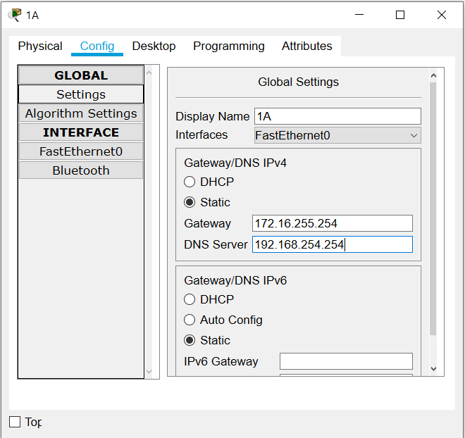

**Step 2.** Click on the Eagle Server, then the Services tab, then select DNS (under SERVICES in the left pane).

Check that the web server’s domain name (**eagle-server.example.com**) and IP address 192.168.254.254 are in the DNS record. Finally, check to make sure that the service for DNS is on.

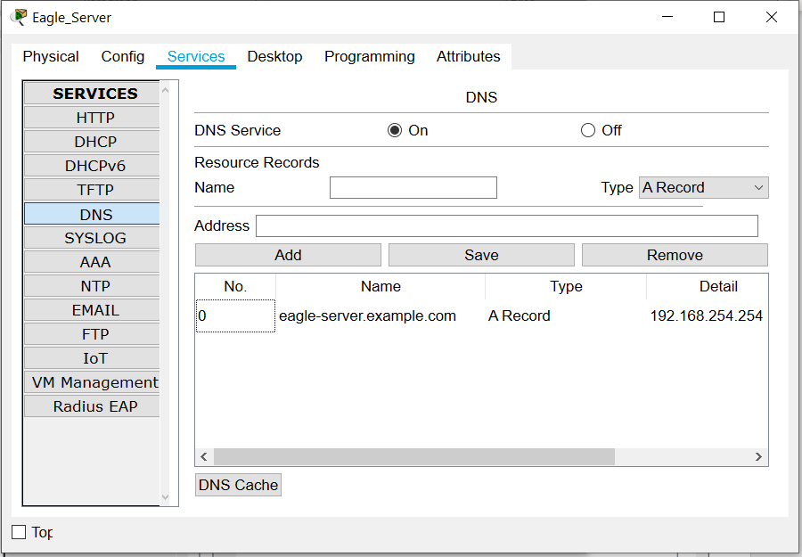

**Step 3.** Still on Eagle Server. Select HTTP under SERVICES in the left pane and check to make sure that HTTP service has been turned on on the server.

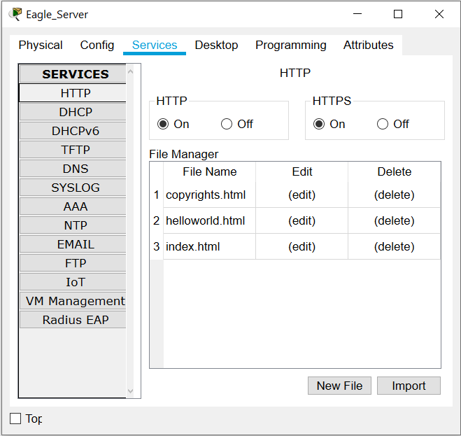

**Step 4.** Click on PC 1A and select the Desktop tab, and then click Web Browser. Type in

**http:eagle-server.example.com** as the URL and click the Go button. The Packet Tracer welcome page, shown below, appears, indicating that the web connection has been successfully established.

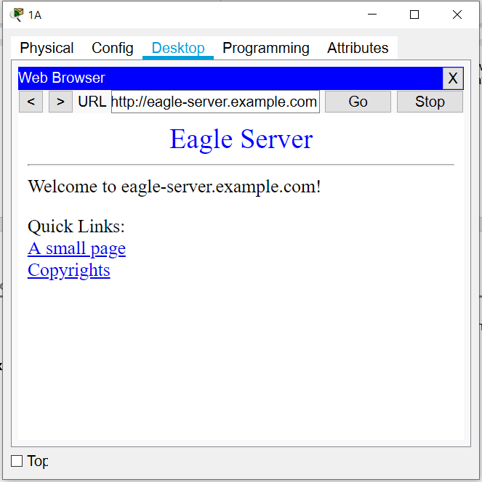

**Checkpoint: please ask your supervisor to check your work**



# Packet Tracer – Network Representation

**Before start:**

#### Review the key concepts related to this computer practical by answering the following questions:

* + What are the 3 categories of network components?
  + List 3 examples of an end device and 3 examples of an intermediary device.
  + What is the major difference between an end device and an intermediary device?
  + What are the three major types of network media?
  + What is the main difference between a client computer and a server computer?
  + How a LAN is different from a WAN?

(If you are unclear about the answers of the questions, refer to week 1 Outline and Highlights slides and/or Readings (Module 1 of Cisco Networking Academy course)

1. Download from course website (Computer Practical – Week 1 folder) the Packet Tracer activity file named: **week1-computer-prac-PKA-b-NetRep.pka**

#### Open the above downloaded Packet Tracer activity file

1. Set up your **User Profile** by typing in your Full Name and UniSA email address in the User Profile window popped up.
2. Follow the instruction given below to complete this activity.

**Topology**

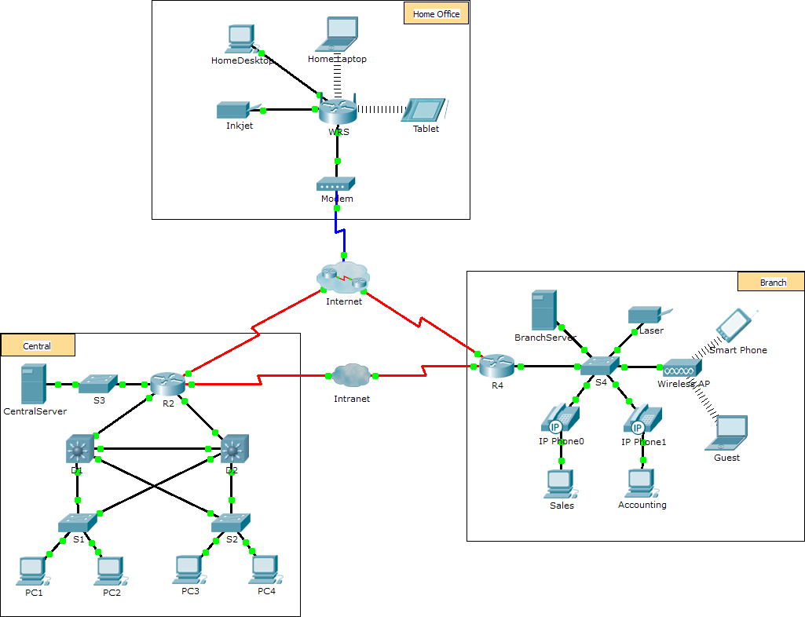

**Objectives**

The network model in this activity incorporates many of the technologies that you will master in your CCNA studies. It represents a simplified version of how a small to medium-sized business network might look. Feel

free to explore the network on your own. When you are ready, proceed through the following steps and answer the questions.

**Note**: It is not important that you understand everything you see and do in this activity. Feel free to explore the network on your own. If you wish to proceed more systematically, follow the steps below. Answer the questions to the best of your ability.

##### Step 1: Identify common components of a network as represented in Packet Tracer.

1. The icon toolbar at the bottom left hand corner has various categories of networking components. You should see categories that correspond to intermediary devices, end devices, and media. The **Connections** category (with the lightning bolt icon) represents the networking media supported by Packet Tracer. There is also an **End Devices** category and two categories specific to Packet Tracer: **Custom Made Devices** and **Multiuser Connection**.
2. List the intermediary device categories. Routers, Switches, Hubs, Wireless Devices, and WAN Emulation
3. Without entering into the Internet cloud or Intranet cloud, how many icons in the topology represent endpoint devices (only one connection leading to them)? 15
4. Without counting the two clouds, how many icons in the topology represent intermediary devices (multiple connections leading to them)? 11
5. How many end devices are **not** desktop computers? 8
6. How many different types of media connections are used in this network topology? 4 (copper, cable, wireless, fiber optic)

##### Step 2: Explain the purpose of the devices.

1. Based on your studies so far, explain the client-server model.

Server provide information and data from this end device to another one via network

Client request and display the information and data that obtained from server through computer using network

1. List at least two functions of intermediary devices.

connect end devices to network

connect individual devices to others to create internetwork

1. List at least two criteria for choosing a network media type.

convenient to connect with end devices

able to handle the power of transmission during the

##### Step 3: Compare and contrast LANs and WANs.

1. In the Packet Tracer network, how many WANs do you see?
2. How many LANs do you see?
3. The Internet in this Packet Tracer network is overly simplified and does not represent the structure and form of the real Internet. Briefly describe the Internet.
4. What are some of the common ways a home user connects to the Internet?

###### Packet Tracer – Network Representation

1. What are some common methods that businesses use to connect to the Internet in your area?

### Step 4. Explore the network

Now that you have had an opportunity to explore the network represented in this Packet Tracer activity, you may have picked up a few skills that you would like to try out. Or maybe you would like the opportunity to explore this network in more detail. Realizing that most of what you see and experience in Packet Tracer is currently beyond your skill level, here are some challenges you might want to attempt. Do not worry if you cannot do them all. You will be a Packet Tracer master user and network designer soon enough.

1. Add a generic PC to the topology and connect it to one of the LANs with a media connection.
   * Which intermediary device would you connect your PC to?
   * What kind of cable do you need to use for this connection?
   * What else does the PC need to send data to other end users? (**Hint**: check how another PC has been configured, by e.g. hovering your mouse over the other PC)
2. Are you able to configure your PC in a similar way? Describe how you do it.

(**Hint**: recall how the two PCs were configured with IP addresses etc. in the “Packet Tracer Navigation” video tutorial you watched in Week 1’s practical)

1. Is there a way to verify that your PC has been connected to the LAN and its configuration is correct such that the PC can communicate with other devices in the same LAN? Describe how you do it.

(**Hint**: again recall what you saw in the “Packet Tracer Navigation” video tutorial about testing the connectivity of the two PCs)

**Checkpoint: please ask your supervisor to check your work of steps 1 to 4**